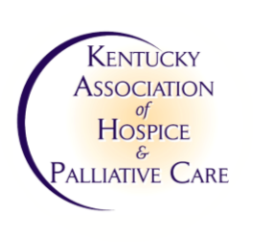


WWW.KAHPC.ORG

KAHPC 2026 Symposium & Exposition
SPECIAL SPONSOR OPPORTUNITIES

August 18-19, 2026
The Marriott Griffin Gate
Lexington, KY

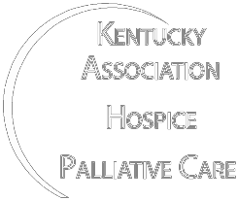
KAHPC is the premier association serving hospice and palliative care professionals in Kentucky. Whether you are looking to showcase your products and services to this niche healthcare market or simply desire to support the efforts of the association, we hope you’ll consider becoming an event sponsor. This is a great opportunity for our sponsors to get your information in front of our audience. Our packages are designed to promote your company and make invaluable contacts throughout the industry.

All sponsors will be listed on the conference brochure, news release(s), and other promotional efforts for this event upon receiving your sponsorship form and payment. All information for the symposium program must be submitted by July 1st, 2026 to ensure inclusion.

SPONSORSHIP LEVELS & ADDITIONAL BENEFITS

Platinum Sponsorship (Contributions of $3,000 or more)
- Logo on hotel key card packets (first come first serve based on registration date)
- Full page ad in conference program
- Recognition of sponsorship in conference program
- Verbal acknowledgment in opening general session
- Plenary Speaker Introduction

Gold Sponsorship (Contributions of $2000 - $2,999)
- 1/2 page ad in conference program
- Recognition of sponsorship in conference program
- Verbal acknowledgment in opening general session
- Company logo/signage displayed on all digital marketing material

Silver Sponsorship (Contributions of $1,500 - $1,999)
- 1/4 page ad in conference program
- Recognition of sponsorship in conference program
- Company logo/signage displayed on all digital marketing material

Bronze Sponsorship (Contributions of $1000- $1,499)
- Recognition of Sponsorship in conference program
- Company logo/signage displayed on all digital marketing material

HOW DO I BECOME A SPONSOR?
Complete and return the sponsorship form (next page). Choose your sponsorship level and register as a sponsor by completing and returning the sponsorship form to the KAHPC office. List your method of payment and then if mailing payment, send to Kentucky Association of Hospice and Palliative Care, 202 West Main Street, Frankfort, KY 40601.

KAHPC reserves the sole responsibility for the assignment of introductions for speakers and events, placement of logos and other information within the virtual conference.
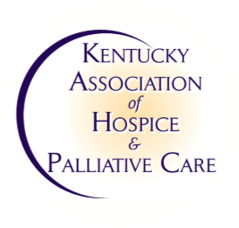


WWW.KAHPC.ORG
KAHPC 2026 Symposium & Exposition
SPONSORSHIP FORM

Platinum Sponsorship/Key Card Packet Sponsor ($3,000+) Gold Sponsorship (Contributions of $2,000 - $2,999)
Silver Sponsorship (Contributions of $1,500 - $1,999)
Bronze Sponsorship (Contributions of $1000- $1,499)

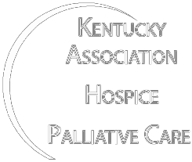

Total Amount Enclosed: $

Contact Person: _________________________________

Phone: _________________________________________

Email: ___________________________________________

Organization: _______________________________________________________________

Address: ___________________________________________________________________

___________________________________________________________________

___________________________________________________________________

We would like to recognize you in our symposium program. To do so, we must have the following information before July 1st, 2026. Please send this info to Edwin Shouse at eshouse@mmlk.com

- High-resolution jpg, png, pdf, or vector version of your company logo

- Advertisement (MUST BE electronic version at least 300 dpi resolution.)

We reserve the right to make minor changes in order to fit it into the program.

